**BCS 345 Lab – JavaFX - TabPane**

***Overview***

Write a JavaFX application that uses a TabPane.

***Part 1***

Create a window according to the following specifications:

1. Create a new project.
2. Add a Driver class and create a main method inside of it.
3. Create an Application class with an override of start.
4. Create a controller class. Event handlers should be defined in this class (do not need them yet).
5. Create an FXML file for the GUI.
   1. Make the root an AnchorPane
   2. Add a TabPane as a child of the AnchorPane
   3. Add a Tab for Messages
   4. Add a Tab for Input Data
   5. Make the title of the window “Lab – JavaFX TabPane”.

Hint: You can do this in code in the start method of the Application class. Just set the title on the primary stage before you call show on it.

You should see the following:

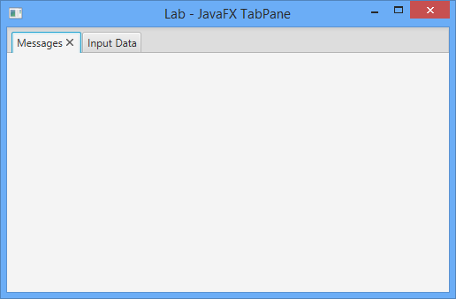

***Part 2***

Update the Messages tab. It should display a Label and a TextArea. The picture below uses a GridPane.

You should see something similar to the following:

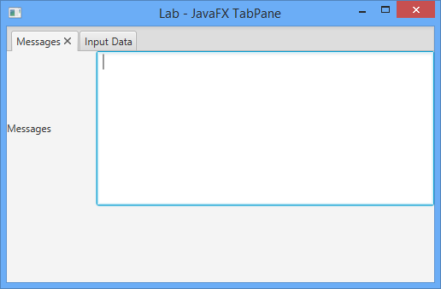

***Part 3***

Add code to input first and last names into the application. You will need to use two Labels, two TextAreas and one Button. Here is what the Input Data tab should look like:

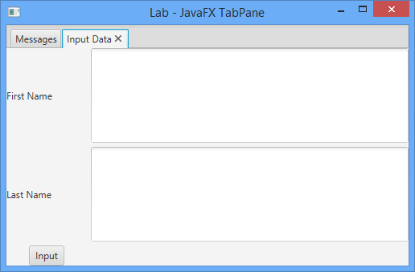

***Part 4***

Add code to handle a button push event for the input button. When the input button is pressed the first and last name should appear in the messages text area (in Messages tab).There should be a space in between the first and last names in the output. Here is what it should look like after pressing the Input button on the Input Data tab:

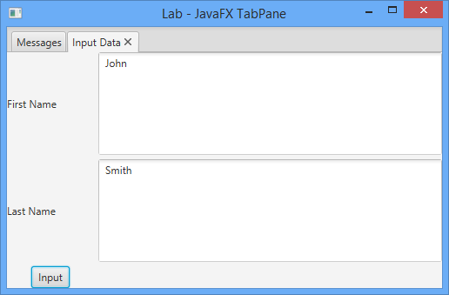 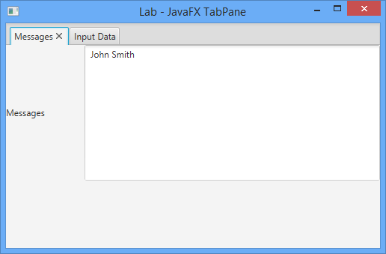

***Part 4***

Add code to append the current name to the end of the messages. Each time the Input button is pressed it should add a new name to the end of the data in the messages text area (instead of overwriting it). For example:

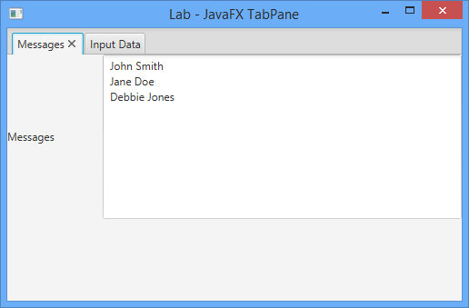

***Part 5***

Add a clear button to the messages tab. The clear button should remove all data from the messages text area. For example:

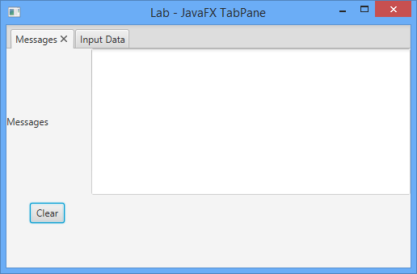

***Part 6***

Update the Input button event handler so that it does the following after copying data into the messages text area:

1. Clears the first and last name text areas after it copies data to the messages text area.
2. Sets the “focus” top the first name control. This means that the blinking cursor will automatically appear in the first name field. This will allow the user to immediately start typing the next name.

***Part 7***

Update the application so that it can read the first and last name from a file. You will need to do the following:

1. Create a new text file in the project directory. The only data it should contain is a first and last name.
2. Add a button to the Input Data tab. Place the button to the right of the Input Button under the last name text area. The button should say “Read From File”.
3. Add an event handler for the Read From File button. This event handler should use a FileChooser to get the selected file from the user. Once you have the selected file you should open it and read the data in (you can store data in a local variable). You should then copy the first and last name into the messages text area.

Here is what it should look like with the ReadFromFile button:

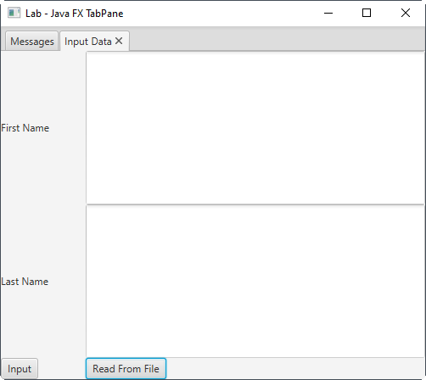

Here is what it should look like when you click the Read From File button (you should see an open file dialog):

